Outer Radius of a Cylinder
# Source: AI Source: Provided by: [Data Path: Persons Table -> ID Column: 1, Name_En Column: Motasem Essam] -> From: [ChatGPT] on [7/25/2026]
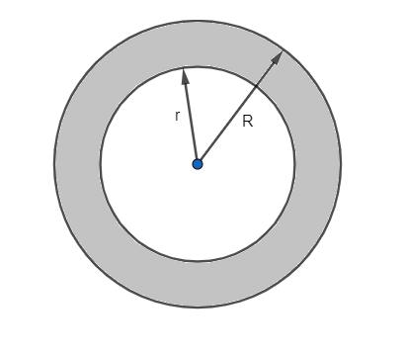
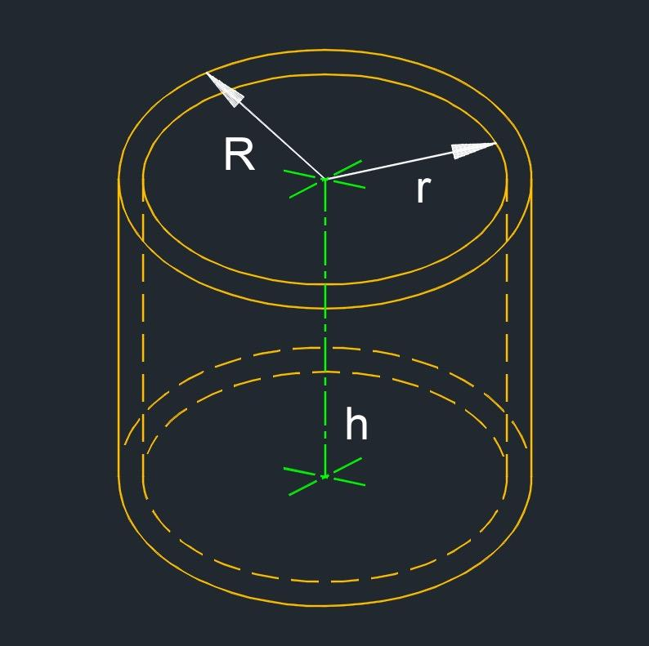
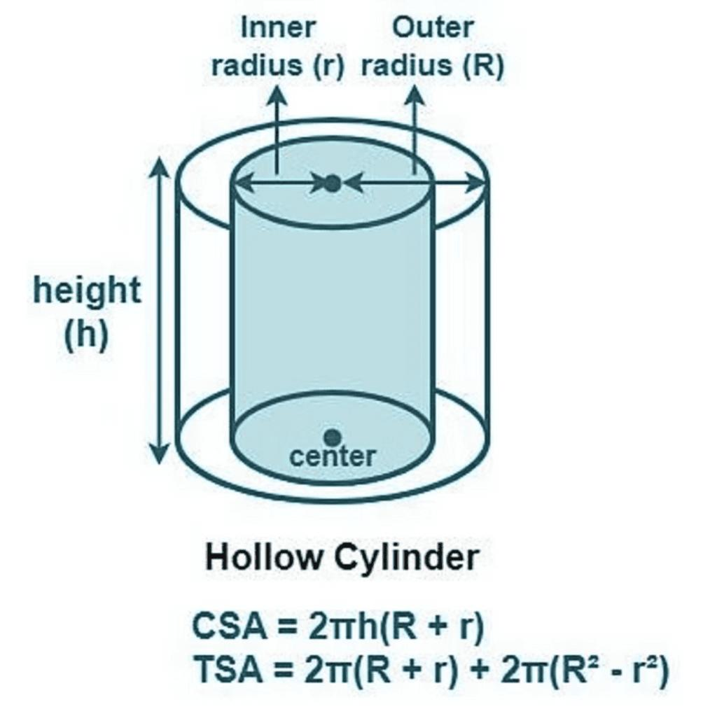

Definition
# Source: AI Source: Provided by: [Data Path: Persons Table -> ID Column: 1, Name_En Column: Motasem Essam] -> From: [ChatGPT] on [7/25/2026]
The outer radius of a cylinder is the distance from the central axis of a cylindrical object to its outer circular boundary, measured perpendicularly to the axis.
For a solid circular cylinder, the outer radius is simply its ordinary radius. For a hollow cylinder, such as a pipe or tube, the outer radius measures the full external size of the cylinder and is larger than its inner radius.
The outer radius is commonly represented by $R$ or $r_{o}$.

Simple Definition
# Source: AI Source: Provided by: [Data Path: Persons Table -> ID Column: 1, Name_En Column: Motasem Essam] -> From: [ChatGPT] on [7/25/2026]
The outer radius is the distance from the center of a cylinder's circular cross-section to its outside edge.
For a hollow pipe, it measures the distance from the center to the external wall, not to the inside opening.
$$\boxed{R=\frac{D_{o}}{2}}$$
where $D_{o}$ is the outer diameter.

Geometric Representation and Components
# Source: AI Source: Provided by: [Data Path: Persons Table -> ID Column: 1, Name_En Column: Motasem Essam] -> From: [ChatGPT] on [7/25/2026]
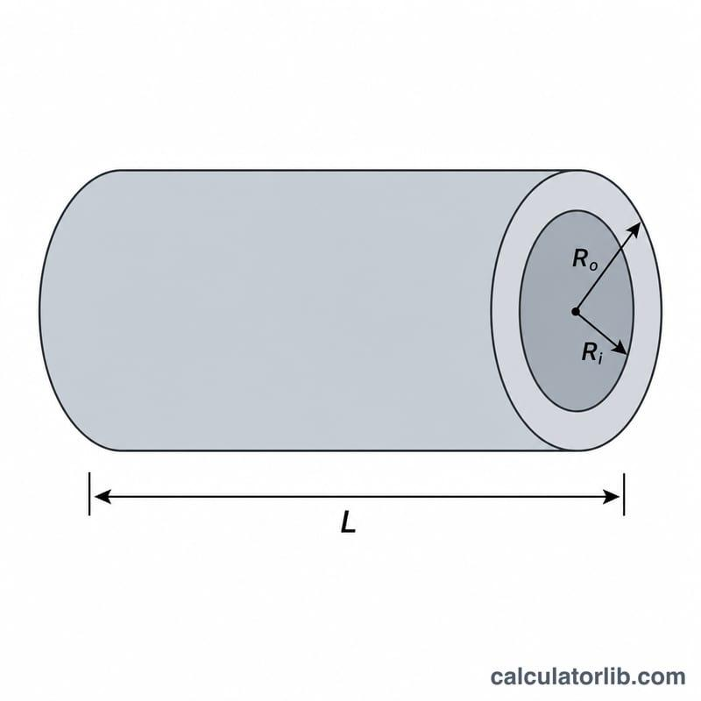
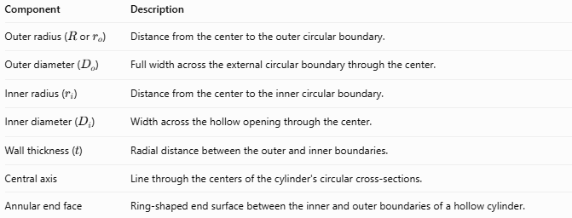
Component | Description
Outer radius ($R$ or $r_{o}$) | Distance from the center to the outer circular boundary.
Outer diameter ($D_{o}$) | Full width across the external circular boundary through the center.
Inner radius ($r_{i}$) | Distance from the center to the inner circular boundary.
Inner diameter ($D_{i}$) | Width across the hollow opening through the center.
Wall thickness ($t$) | Radial distance between the outer and inner boundaries.
Central axis | Line through the centers of the cylinder's circular cross-sections.
Annular end face | Ring-shaped end surface between the inner and outer boundaries of a hollow cylinder.
For a hollow cylinder with a nonzero wall thickness:
$$R>r_{i}$$
and:
$$\boxed{t=R-r_{i}}$$

Types and Classification

Outer Radius of a Solid Cylinder
# Source: AI Source: Provided by: [Data Path: Persons Table -> ID Column: 1, Name_En Column: Motasem Essam] -> From: [ChatGPT] on [7/25/2026]
For a solid circular cylinder, there is no hollow opening. Its outer radius is the ordinary radius of its circular base.
$$\boxed{R=\frac{D_{o}}{2}}$$

Outer Radius of a Hollow Cylinder
# Source: AI Source: Provided by: [Data Path: Persons Table -> ID Column: 1, Name_En Column: Motasem Essam] -> From: [ChatGPT] on [7/25/2026]
For a hollow cylinder, the outer radius extends from the central axis to the outside boundary of the cylindrical wall.
It is greater than the inner radius:
$$\boxed{R>r_{i}}$$

Outer Radius of a Cylindrical Pipe
# Source: AI Source: Provided by: [Data Path: Persons Table -> ID Column: 1, Name_En Column: Motasem Essam] -> From: [ChatGPT] on [7/25/2026]
For a pipe, the outer radius determines the external width and contributes to the amount of material required to construct the pipe.
The outer diameter is:
$$\boxed{D_{o}=2R}$$

Outer Radius of an Oblique Circular Cylinder
# Source: AI Source: Provided by: [Data Path: Persons Table -> ID Column: 1, Name_En Column: Motasem Essam] -> From: [ChatGPT] on [7/25/2026]
An oblique circular cylinder also has an outer radius measured within its circular base plane, from the base center to its circumference. The inclination of its axis does not change the definition of radius.

Mathematical Formulas

Outer Radius from the Outer Diameter
# Source: AI Source: Provided by: [Data Path: Persons Table -> ID Column: 1, Name_En Column: Motasem Essam] -> From: [ChatGPT] on [7/25/2026]
$$\boxed{R=\frac{D_{o}}{2}}$$

Outer Radius from the Outer Circumference
# Source: AI Source: Provided by: [Data Path: Persons Table -> ID Column: 1, Name_En Column: Motasem Essam] -> From: [ChatGPT] on [7/25/2026]
The outer circumference is:
$$C_{o}=2πR$$
Therefore:
$$\boxed{R=\frac{C_{o}}{2π}}$$

Outer Radius from the Outer Circular Area
# Source: AI Source: Provided by: [Data Path: Persons Table -> ID Column: 1, Name_En Column: Motasem Essam] -> From: [ChatGPT] on [7/25/2026]
If the area enclosed by the outer circular boundary is $A_{o}$:
$$A_{o}=πR^{2}$$
Therefore:
$$\boxed{R=\sqrt{\frac{A_{o}}{π}}}$$
This is the area of the full outer circle, not the ring-shaped material cross-section.

Outer Radius from the Inner Radius and Wall Thickness
# Source: AI Source: Provided by: [Data Path: Persons Table -> ID Column: 1, Name_En Column: Motasem Essam] -> From: [ChatGPT] on [7/25/2026]
Since the wall thickness is the difference between the outer and inner radii:
$$t=R-r_{i}$$
Rearranging:
$$\boxed{R=r_{i}+t}$$

Outer Radius from the Volume of Hollow Cylindrical Material
# Source: AI Source: Provided by: [Data Path: Persons Table -> ID Column: 1, Name_En Column: Motasem Essam] -> From: [ChatGPT] on [7/25/2026]
For a hollow cylinder with outer radius $R$, inner radius $r_{i}$, and height $h$, the volume of the cylindrical material is:
$$V=πh\left(R^{2}-r_{i}^{2}\right)$$
Solving for the outer radius:
$$\boxed{R=\sqrt{\frac{V}{πh}+r_{i}^{2}}}$$

Worked Examples
# Source: AI Source: Provided by: [Data Path: Persons Table -> ID Column: 1, Name_En Column: Motasem Essam] -> From: [ChatGPT] on [7/25/2026]
Example 1 — Calculate the Outer Radius from the Outer Diameter
A hollow cylindrical pipe has an outer diameter of $24\text{ cm}$. Find its outer radius.
Solution:
$$R=\frac{D_{o}}{2}$$
$$R=\frac{24}{2}$$
$$\boxed{R=12\text{ cm}}$$
Example 2 — Calculate the Outer Radius from the Outer Circumference
The outer circumference of a cylindrical pipe is $40π\text{ mm}$. Find its outer radius.
Solution:
$$R=\frac{C_{o}}{2π}$$
$$R=\frac{40π}{2π}$$
$$\boxed{R=20\text{ mm}}$$
Example 3 — Calculate the Outer Radius from the Inner Radius and Wall Thickness
A hollow cylinder has an inner radius of $5\text{ cm}$ and a wall thickness of $2\text{ cm}$. Find its outer radius.
Solution:
$$R=r_{i}+t$$
$$R=5+2$$
$$\boxed{R=7\text{ cm}}$$
Example 4 — Calculate the Outer Radius from the Material Volume
A hollow cylinder has a material volume of $144π{\text{ cm}}^{3}$, a height of $8\text{ cm}$, and an inner radius of $3\text{ cm}$. Find its outer radius.
Solution:
$$R=\sqrt{\frac{V}{πh}+r_{i}^{2}}$$
$$R=\sqrt{\frac{144π}{8π}+3^{2}}$$
$$R=\sqrt{18+9}$$
$$\boxed{R=3\sqrt{3}\text{ cm}≈5.20\text{ cm}}$$

How the Outer Radius Affects a Hollow Cylinder
# Source: AI Source: Provided by: [Data Path: Persons Table -> ID Column: 1, Name_En Column: Motasem Essam] -> From: [ChatGPT] on [7/25/2026]
For a hollow cylinder with a fixed inner radius and height:
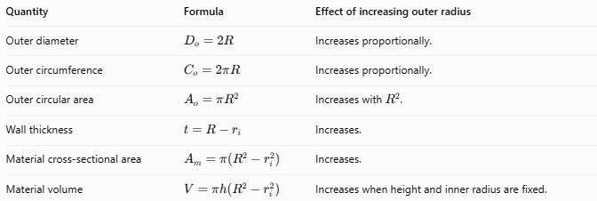
Quantity | Formula | Effect of increasing outer radius
Outer diameter | $$D_{o}=2R$$ | Increases proportionally.
Outer circumference | $$C_{o}=2πR$$ | Increases proportionally.
Outer circular area | $$A_{o}=πR^{2}$$ | Increases with $R^{2}$.
Wall thickness | $$t=R-r_{i}$$ | Increases.
Material cross-sectional area | $$A_{m}=π\left(R^{2}-r_{i}^{2}\right)$$ | Increases.
Material volume | $$V=πh\left(R^{2}-r_{i}^{2}\right)$$ | Increases when height and inner radius are fixed.

Outer Radius Compared with Related Measurements
# Source: AI Source: Provided by: [Data Path: Persons Table -> ID Column: 1, Name_En Column: Motasem Essam] -> From: [ChatGPT] on [7/25/2026]
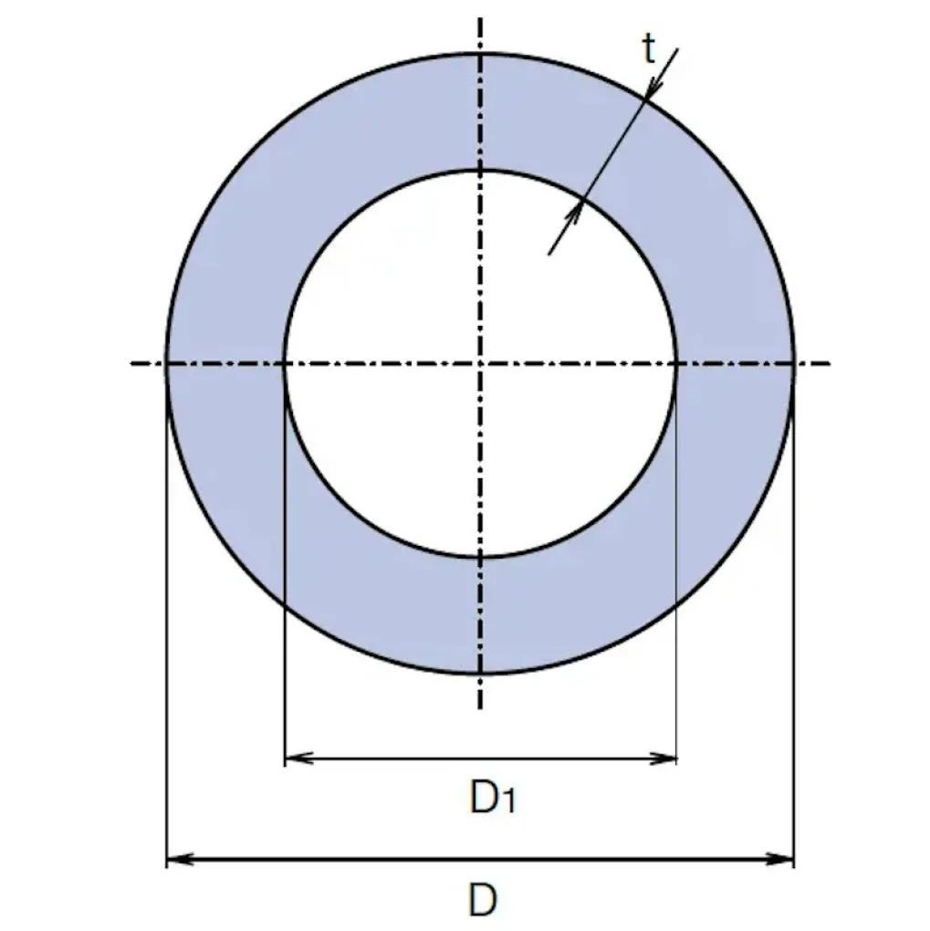
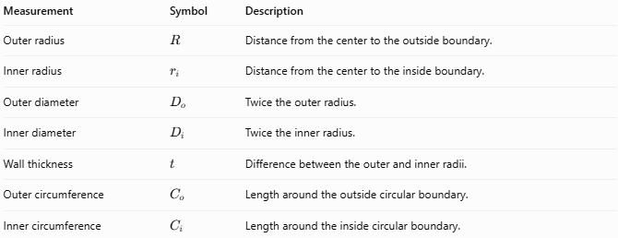
Measurement | Symbol | Description
Outer radius | $$R$$ | Distance from the center to the outside boundary.
Inner radius | $$r_{i}$$ | Distance from the center to the inside boundary.
Outer diameter | $$D_{o}$$ | Twice the outer radius.
Inner diameter | $$D_{i}$$ | Twice the inner radius.
Wall thickness | $$t$$ | Difference between the outer and inner radii.
Outer circumference | $$C_{o}$$ | Length around the outside circular boundary.
Inner circumference | $$C_{i}$$ | Length around the inside circular boundary.
The fundamental relationships are:
$$\boxed{D_{o}=2R}$$
$$\boxed{D_{i}=2r_{i}}$$
$$\boxed{t=R-r_{i}}$$

Applications
# Source: AI Source: Provided by: [Data Path: Persons Table -> ID Column: 1, Name_En Column: Motasem Essam] -> From: [ChatGPT] on [7/25/2026]
The outer radius is useful in:
- Pipe design: determining external dimensions and clearance.
- Plumbing: checking whether pipes fit into connectors or supports.
- Mechanical engineering: specifying shafts, sleeves, bearings, and cylindrical housings.
- Construction: calculating the external dimensions of cylindrical structures.
- Manufacturing: estimating material requirements for hollow cylindrical components.
- Fluid systems: distinguishing external pipe dimensions from internal flow dimensions.
Practical note: For a pipe, the outer radius alone does not determine its flow capacity. The inner radius is needed to calculate the internal cross-sectional area.

Key Points
# Source: AI Source: Provided by: [Data Path: Persons Table -> ID Column: 1, Name_En Column: Motasem Essam] -> From: [ChatGPT] on [7/25/2026]
- The outer radius measures from the central axis to the external circular boundary.
- It is commonly represented by $R$ or $r_{o}$.
- The outer diameter is twice the outer radius.
- In a hollow cylinder, the outer radius exceeds the inner radius.
- Wall thickness equals the outer radius minus the inner radius.
- The outer radius determines external dimensions but is not sufficient by itself to determine a hollow cylinder's internal capacity.
- A solid cylinder's outer radius is its ordinary base radius.

Conclusion
# Source: AI Source: Provided by: [Data Path: Persons Table -> ID Column: 1, Name_En Column: Motasem Essam] -> From: [ChatGPT] on [7/25/2026]
The outer radius of a cylinder defines the distance from its central axis to its external circular boundary. It is particularly important for hollow cylinders, pipes, and tubes because it describes their external size and helps determine wall thickness and material volume.
The three most important formulas are:
$$\boxed{R=\frac{D_{o}}{2}}$$
$$\boxed{R=r_{i}+t}$$
$$\boxed{V=πh\left(R^{2}-r_{i}^{2}\right)}$$
The last formula calculates the volume of material in a hollow cylinder when its outer radius, inner radius, and height are known.

